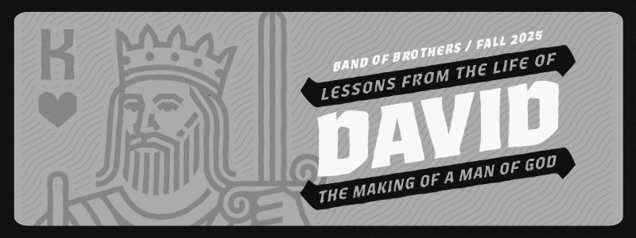

BAND *of* BROTHERS FALL SERIES 2025 – WEEK 3

**WHEN A MAN AFTER GOD’S OWN HEART LOSES HEART**

*“They have driven me today from my share in the Lord’s inheritance and have said, ‘Go, serve other gods.’ Now do not let my blood fall to the ground far from the presence of the Lord. The king of Israel has come out to look for a flea—as one hunts a partridge in the mountains.”*

*–* 1 Samuel 26:19-20 ESV

* **A Man on the Run**
  + - * + David’s life has been completely flipped upside down

One day, he was the hero who defeated Goliath

The next day, he was an enemy of the state

He had nothing to his name

No army, palace, or safety net

David is full of fear

* + - * + Fear has the potential to drive one toward God or toward self-reliance

We all face fear in our lives

The question is, what will you do with it?

This is a moment where everything you claim to believe about God is going to be tested

Is he really in control?

Is he truly sovereign?

* + - * + David will show us both sides of this coin

Sometimes he runs to God

Sometimes he just runs

* This is what makes David so relatable
* **God’s sovereignty in David’s desperation**
  + - * + Nob – God Provides

David shows up hungry and scared

Lies to the priest to protect himself

God provides the consecrated bread to meet his need

Takes Goliath’s sword

* + - * + Gath – God Protects

With Goliath’s sword, David flees to Gath, Goliath’s hometown

He is quickly recognized and begins to panic

Pretends to be insane just to escape

* + - * + Adullam – God Surrounds

Runs to a cave in Adullam to hide alone and afraid

God sends 400 men – distressed, in debt, and discontented – and puts them under David’s care

This group eventually becomes the core of his army

God is shaping him into the leader he called him to be

* + - * + God is still in control
* These moments are not high points in David’s life
* They are moments of fear, panic, and anxiety
* Yet, in all of them, God is still in control
* David’s fear and failure don’t derail God’s faithfulness
  + - * God’s sovereignty is bigger than David’s mistakes
      * God is not waiting for David to get it right
      * He is guiding David even through his weakness
    - Even when we rely on ourselves, God is still ruling, working, and shaping us
* **David’s confession** 
  + - * + After all this, David writes Psalm 56

*“When I am afraid, I put my trust in you.”* – Psalm 56:3 ESV

* + Notice he doesn’t say “I am never afraid”
  + He admits the fear, but chooses to trust God through it
  + This is David looking back and saying…

“…*even when I panicked at Nob…”*

*“…even when I humiliated myself at Gath…”*

*“…even when I was alone in the cave…”*

*“God was still in control and I could trust him with my life”*

* + David was learning to trust God’s sovereignty through fear and failure
  + Saul is doing the opposite
* **Saul’s descent into darkness**
  + - * + Saul had already disobeyed God on multiple occasions

He never repented of his sin

He justifies himself and tries to hold on to power

Saul is no longer concerned about God’s Kingdom, only his own

* + - * + Darkness on display
  + Doeg the Edomite tells Saul that David visited the Priests at Nob
  + Instead of seeking God, Saul rages
* Orders the murder of all the priests and his own men refuse
* Doeg carries out the slaughter
* 85 priests and the entire town of Nob are killed
* Saul is now fighting against the Lord
* His fear, pride, and power led him to sinful decisions   
  + - * + God’s sovereignty still stands
  + Abiathar escapes and flees to David

*David said to Abiathar, “I knew on that day, when Doeg the Edomite was there, that he would surely tell Saul. I have occasioned the death of all the persons of your father’s house.* – 1 Samuel 22:22 ESV

* + David feels the weight of what happened at Nob
  + He takes responsibility for his fear based decisions and their consequences
  + David’s failure and Saul’s fury cannot derail God’s faithfulness
* Even when our sin has real consequences
* Even when we feel guilt and regret
* God’s sovereignty is unshaken
* **Trusting God’s timing & sovereignty** 
  + - * + This was the lesson God was teaching David throughout these chapters
        + God even uses Jonathan to encourage David

*“Do not fear, for the hand of Saul my father shall not find you. You shall be king over Israel, and I shall be next to you. Saul my father also knows this.”* – 1 Samuel 23:17 ESV

* + - * + David has to be confused at this reminder of God’s sovereignty
    - He is still being pursued by Saul
    - He was anointed King, but still running
    - He is hiding in a cave
  + We’re about to see if David truly believes this

*And he came to the sheepfolds by the way, where there was a cave, and Saul went in to relieve himself. Now David and his men were sitting in the innermost parts of the cave.* – 1 Samuel 24:3 ESV

* + Saul is presented to David on a silver platter
  + David’s men tell him this is the Lord giving him Saul
  + Instead of killing Saul he cuts off some of his robe
    - David is struck by his conscience

*The LORD forbid that I should do this thing to my lord, the LORD’s anointed, to put out my hand against him.* – 1 Samuel 24:6 ESV

* + - * + The LORD’s Anointed
  + Even in this small action, David recognizes God’s sovereignty
  + To kill Saul would have been to take vengeance in his own hands

“*See, my father, see the corner of your robe in my hand. I will not put out my hand against my lord, for he is the LORD’s anointed.”* – 1 Samuel 24:11 ESV

* + David realizes Saul is King because God put him there
    - Only God has the right to remove him
  + David is trusting God’s timing and plan
* **Submission over self-promotion**
  + - * + David chooses obedience over convenience
  + We are often tempted to take matters into our own hands
  + Trusting God’s sovereignty means refusing to shortcut His plan
    - Even if it means more waiting
  + The very next story shows David about to revert to taking vengeance

**The Insult**

*“Who is David? Who is the son of Jesse?”* – 1 Samuel 25:10 ESV

**The Response**

“Every man strap on his sword!” – 1 Samuel 25:13

* + David is ready to kill Nabal and every male in his household
  + Nabal’s wife acts quickly and restrains David and his men
    - The LORD uses Abigail to remind David of His sovereignty

*“Blessed be your discretion, and blessed be you, who have kept me this day from bloodguilt.”* – 1 Samuel 25:26 ESV

* + God is shaping David’s heart to trust Him rather than do it himself
  + We’ve all been in moments like this
    - Will we listen to the Lord or take matters into our own hands?

“Vengeance is mine, I will repay, says the Lord.” – Romans 12:19 ESV

* + Let God fight your battles and vindicate you in His time
* **David’s fear and flight** 
  + - * + David has seen time and time again the provision of God
  + But he still loses heart

*“Then David said in his heart, ‘Now I shall perish one day by the hand of Saul.’”* - 1 Samuel 27:1 ESV

* + David stops listening to God and listens to his fear
  + Leads him to think the safest place is with the Philistines
    - He lives under the protection of King Achish
    - David is surviving, but spiritually drifting
  + David’s fear leads him to self-reliance, but God’s sovereignty still holds
  + God is putting David where he wants, even when David isn’t following Him
  + God’s plan does not collapse when we stumble
    - Self-reliance may feel safe, but leads to running from God
    - God’s grace meets us even when we run
    - He shapes us through it   
      * + God is in control
* God’s sovereignty does not depend on our perfection
* He provides in our fear and failure
* Every season is an invitation to trust His timing

**Discussion Questions**

What did God teach you today about allowing your fears to drive your decisions rather than trust in Him?

Describe a time when you were tempted to take matters into your own hands instead of waiting on God’s timing. What was the outcome?

Have you experienced God’s faithfulness even after a failure or bad decision? In what way, and how should that encourage you today?

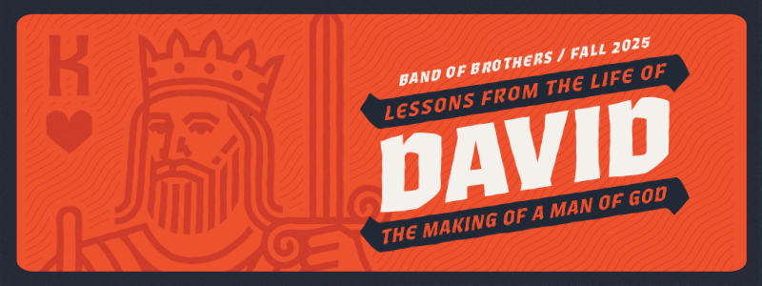

BAND *of* BROTHERS FALL SERIES 2025 – WEEK 4 HOMEWORK

**WEEK 4 – The Best Laid Scheme of Mice and Men**

In this lesson, we will pick up the story of David’s second attempt to seek refuge among the Philistines. This is one of the many occasions when David tried to come up with his own plan for solving the problem of Saul.

PASSAGE: 1 Samuel 27, 28-31

DEVOTIONARY™: Pages 125-158

* Use the Devotionary™ reading like a commentary, reading it to help shed light on passages you find difficult to understand or to gain a better understanding of the overall context. But try to read as much of it as you possibly can. As you read, jot down any thoughts that stand out to you.
* In last week’s lesson, we saw how David’s attempt to take matters into his own hands got him in deeper trouble. In Chapter 27, David makes a return visit to the Philistine city of Gath. Revisit Chapter 21:10-15 to refresh your memory of what happened the first time. Why do you think David returned to the scene of this embarrassing and potentially deadly event?

In what ways did David employ deceit and deception to win over the king of Gath this time?

What was David really doing while living among the Philistines?

How did David employ deceit to prevent the Philistines from discovering what he was doing?

* In Chapter 28, the author refocuses our attention on Saul. What is it that Saul does in this chapter that reveals his distance from God?

What was the result of his consultation with the witch?

What was the pronouncement that God made in verse 19?

* Chapters 29-30 provide the aftermath of Saul’s divine encounter with the prophet. But what does Chapter 30 reveal about David’s decision to live among the Philistines?

How can you see the hand of God protecting David?

* Look closely at Chapter 30, and write down the less-than-ideal results from David’s strategy to seek refuge among the Philistines. What happened?

What did David do that revealed he was learning to trust God rather than himself?

What did God do to prove His sovereignty and faithfulness?

* How does God prove His sovereignty and power in Chapter 31? How did God fulfill His promise to pay back Saul for his disobedience?